**package** connection;

**import** org.bson.Document;

**import** com.mongodb.client.MongoClient;

**import** com.mongodb.client.MongoClients;

**import** com.mongodb.client.MongoCollection;

**import** com.mongodb.client.MongoDatabase;

**import** com.mongodb.client.MongoIterable;

**import** com.mongodb.client.model.Filters;

**import** com.mongodb.client.model.Updates;

**import** com.mongodb.client.FindIterable;

**public** **class** java {

**public** **static** **void** main(String[] args){

MongoClient mongoClient = MongoClients.*create*("mongodb://localhost:27017");

MongoDatabase database = mongoClient.getDatabase("vit");

MongoCollection<Document> collection = database.getCollection("products");

FindIterable<Document> Documents = collection.find(Filters.*and*(Filters.*gte*("price", 700), Filters.*lte*("price", 900)));

**for** (Document document : Documents){

System.***out***.println(document);

}

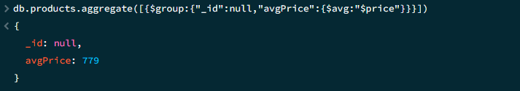

**package** connection;

**import** java.util.*;

**import** org.bson.Document;

**import** com.mongodb.client.MongoClient;

**import** com.mongodb.client.MongoClients;

**import** com.mongodb.client.MongoCollection;

**import** com.mongodb.client.MongoDatabase;

**import** com.mongodb.client.AggregateIterable;

**import** **static** com.mongodb.client.model.Aggregates.*group*;

**import** **static** com.mongodb.client.model.Accumulators.*avg*;

**public** **class** java {

**public** **static** **void** main(String[] args){

MongoClient mongoClient = MongoClients.*create*("mongodb://localhost:27017");

MongoDatabase database = mongoClient.getDatabase("vit");

MongoCollection<Document> collection = database.getCollection("products");

AggregateIterable<Document> result = collection.aggregate(Arrays.*asList*(

*group*(**null**, avg("avgPrice", "$price"))

));

**for** (Document doc : result) {

System.***out***.println("Average Price: " + doc.getDouble("avgPrice"));

}

}

}

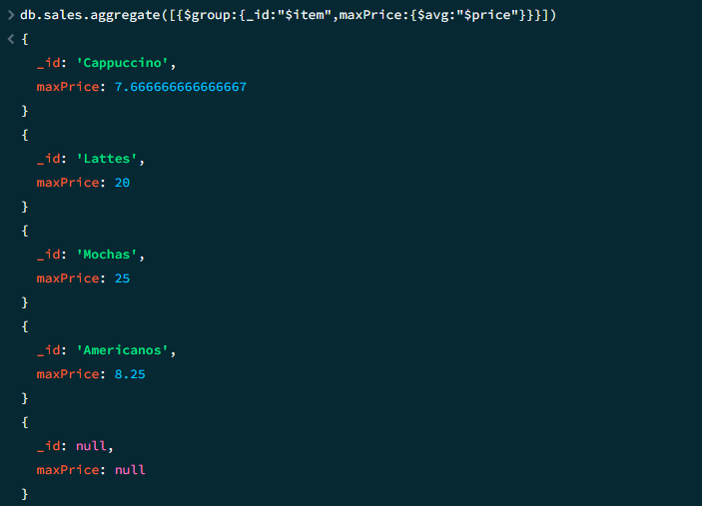

**package** connection;

**import** java.util.*;

**import** org.bson.Document;

**import** com.mongodb.client.MongoClient;

**import** com.mongodb.client.MongoClients;

**import** com.mongodb.client.MongoCollection;

**import** com.mongodb.client.MongoDatabase;

**import** com.mongodb.client.AggregateIterable;

**import** **static** com.mongodb.client.model.Aggregates.*group*;

**import** **static** com.mongodb.client.model.Accumulators.*max*;

**public** **class** java {

**public** **static** **void** main(String[] args){

MongoClient mongoClient = MongoClients.*create*("mongodb://localhost:27017");

MongoDatabase database = mongoClient.getDatabase("vit");

MongoCollection<Document> collection = database.getCollection("sales");

AggregateIterable<Document> Documents = collection.aggregate(Arrays.*asList*(

*group*("$item", *max*("maxPrice", "$price"))

));

**for** (Document document : Documents){

System.***out***.println(document);

}}

}

package connection;

import org.bson.Document;

import com.mongodb.client.MongoClient;

import com.mongodb.client.MongoClients;

import com.mongodb.client.MongoCollection;

import com.mongodb.client.MongoDatabase;

import static com.mongodb.client.model.Aggregates.*;

import static com.mongodb.client.model.Accumulators.*;

import static com.mongodb.client.model.Sorts.*;

import java.util.Arrays;

public class java {

public static void main(String[] args) {

try (MongoClient mongo = MongoClients.create("mongodb://localhost:27017")) {

MongoDatabase db = mongo.getDatabase("vit");

MongoCollection<Document> sales = db.getCollection("sales");

sales.aggregate(Arrays.asList(

group("$item", max("maxPrice", "$price"), addToSet("sizes", "$size")

),

sort(descending("maxPrice"))

)).forEach((Document doc) -> {

System.out.printf("%-10s: $%2d (Sizes: %s)%n", doc.getString("_id"), doc.getInteger("maxPrice"),doc.getList("sizes", String.class));

});

}

}

}